Part 1 (Points: 40 of 100)

Assignment 4

This time you are going to create a speedometer calculator. Below is the formula and some basic logic about why this is important. In this program you will ask the user for the tire sizes (old & new). Then you will calculate the difference between the actual speed of the vehicle and what the speedometer shows in 10 mph increments from 10-100. You will save all of actual speeds in an array. For example and using the ratio difference below, at 60 mph on the speedometer the actual speed of the vehicle is 66 mph. so you will store the actual speed in the array of 66 mph. For the display, see the picture below. Oh yeah, don’t forget about giving the user the ability to run the program as many times as they want, again like in the picture below.

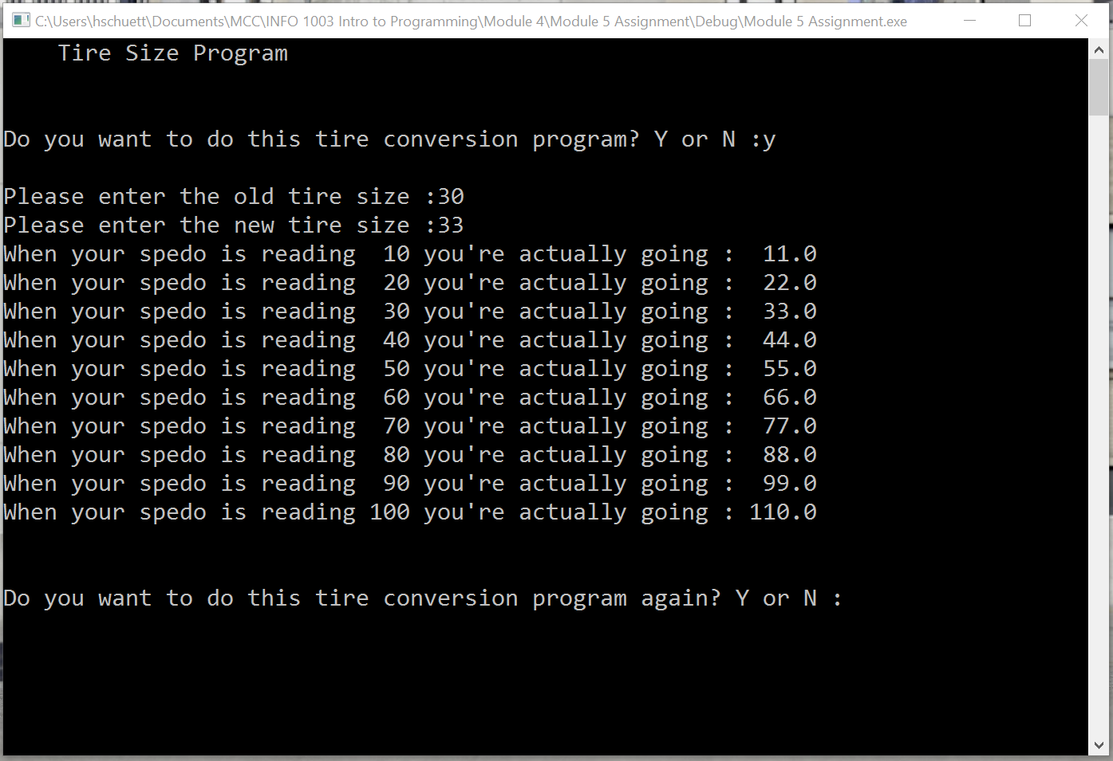

Since this is a ratio problem we will be dealing with it in that manner. What that means is that if we have a tire diameter that is 30” (inches) and we increase the size to 33” we have a 10% increase in size therefore our speedometer will also be off by that same 10%.
Formula: tireRatio = newTireSize / oldTireSize

The Speedometer
- The speedometer in almost every vehicle runs off the speed of the transmission, not the actual tires. However, some old Volkswagens and other makes and models do have a speedometer cable that runs directly to the front wheels, but this is extremely uncommon. The gears that are rotating inside the transmission will spin at a known rate for every speed the vehicle travels at, and this is transferred to the speedometer via a magnetic current known as an "Eddy Current." The faster the gears spin, the more electromagnetic field is created and the further the needle goes up on the speedometer in the dashboard. Therefore, as long as the wheels and tires are stock sized, the speedometer will read accurately. Let's look at why changing tire size would affect the speedometer.

Altered Tire Size
- For those who have off-road vehicles and put larger tires on for better performance on the trail, the speedometer will be affected. Since there is more surface area and a larger circumference on the outside edge of the tire, the wheels will actually spin slower at any given speed than the stock setup would. Therefore, the speedometer in the vehicle will read less than the actual speed that is being traveled. Likewise, a smaller tire on a low-rider, for instance, will have to spin faster than a stock one to maintain the same speed, and therefore will cause the speedometer to read faster than the actual rate traveled. It is important to know this for local speed laws and safety in general. The faster the vehicle goes, the further off the speedometer will be. When the vehicle is sitting still, the speedometer will read zero with either set of tires on. However, once the vehicle begins rolling, the discrepancy grows.

Things to Know
- When the tire and wheel size are drastically changed on newer vehicles, the warranty may be affected adversely, or even completely voided. Changing the tire size affects the way the brakes work, it affects wear and tear on the drive train and engine, and it affects the way the vehicle handles in all road conditions. If going to bigger tires, the brakes will have more stress on them due to more rotating mass to slow. They may also cause the vehicle to handle and steer differently. If much smaller wheels are applied, the vehicle could sit dangerously low and have turning issues. If the vehicle has small rims and tires and experiences a blowout, the frame could actually scrape on the ground, causing a very dangerous situation. Check local ordinances before changing tire size to ensure that no laws are broken and safety is not compromised.
Sourced from: http://www.ehow.com/how-does_4926157_tire-size-affects-speedometer-car.html

